BULK - APPLICATIONS

# Time study

|  |  |
| --- | --- |
| **Action** | **Manual time (seconds/minutes)** |
| Checks case | 140 s/2.33 m |
| Sends SPEC/MEMO | 195 s/3.25 m |
| Check SPEC/MEMO | 335/5.58 m |
|  |  |
|  |  |
| Total time per case | 335/5.58 m |
| Script processing time per case: | 6.5-7.00 s |

## Additional time savings considerations

With this automated process, a HSR does not need to:

* Send an appointment letter
* Send a NOMI
* Potentially follow up case that is ready for denial at day 30
* Search ECF for pending verifications
* Case note actions

## What the script will do:

1. User selects file that contains Application interview information
2. Read from the excel sheet and check the case to ensure an interview has not already been completed if so it will update excel with complete status if the interview has not been completed:

User Script reads the following:

* 1. Case number: COL 1
  2. Income type: COL 9
  3. Correct #: COL 12
  4. Amount: COL 13
  5. COLA: COL 14

1. For each case
   1. Enter the case #
   2. Check SNAP and/or HC is active in STAT/PROG
   3. Reads for if the interview has been completed
   4. If not sends the appointment letter
      1. Search UNEA to find the correct span
         1. Updated the VA income information in prospective section.
         2. If SNAP is active, updates the PIC.
         3. If HC is active, updates the HC pop up
      2. Saves the information
   5. Makes case note re: VA income updated.
   6. Send SPEC/MEMO to recipient re: HC veterans’ services.
   7. Creates notes on the spreadsheet re: status of case and if any errors exist

# Case note text

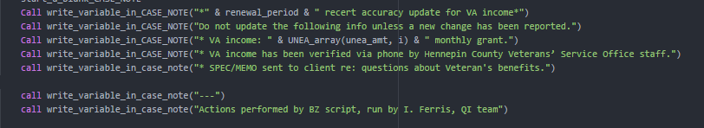

# MEMO text

If you have any questions about veteran's benefits, please contact the Hennepin County Veterans’ Service Office at 612-348-3300. Veterans’ Services has staff at the Government Center, the South Minneapolis Human Service center, and Maple Grove. You may also make an appointment at a variety of regional locations.

Even if you are already in receipt of compensation or pension, your benefit amount may be able to be increased.

If you are interested in speaking with someone regarding Veteran’s benefits, or if you have questions about this notice, please call the Hennepin County Veterans’ Service Office at 612-348-3300. Thank you.

Column template for script to run properly

|  |  |
| --- | --- |
| **Information** | **Column** |
| Case number | 1 |
| PMI | 2 |
| Income type | 9 |
| Claim number | 11 |
| Correct claim # | 12 |
| Amount | 13 |
| COLA | 14 |
| Status | 15 |
| Notes | 16 |